PROJECT REPORT

AML TRANSACTION & FRAUD ANALYSIS USING MICROSOFT POWER BI

1. Introduction
Anti-Money Laundering (AML) refers to the process of identifying, preventing and monitoring illegal financial activities, including money laundering, financial fraud and suspicious transactions.
In today's digital banking environment, financial transactions take place on a large scale. Therefore, identifying fraudulent activities and monitoring suspicious transactions have become important for financial institutions.
The project AML Transaction & Fraud Analysis using Microsoft Power BI focuses on analysing financial transaction data, identifying fraudulent activities and presenting important financial information through interactive dashboards.
Power BI is used to transform raw transaction data into meaningful visual reports that help users understand transaction patterns, fraud distribution and financial risks.

2. Objectives of the Dashboard
The main objectives of this dashboard are:
- To analyse financial transaction data using Microsoft Power BI.
- To identify and monitor fraudulent transactions.
- To compare fraudulent and non-fraudulent transactions.
- To analyse transaction trends based on timestamps.
- To monitor important financial performance indicators.
- To understand different types of AML alerts.
- To provide interactive filters for better data analysis.
- To support effective risk management and financial decision-making.

3. Overview of the Dataset
The dashboard uses financial transaction-related data to analyse transaction activities and identify potential fraud.
The dataset contains information related to the following areas:
A. Transactions
- Transaction ID
- Transaction amount
- Transaction timestamp
- Fraud status (IS_FRAUD)
- Transaction-related information
B. Accounts
- Account identification
- Account-related information
- Account details used for transaction analysis
C. Alerts
- Alert ID
- Alert type
- Suspicious transaction alerts
- Alert-related information
These datasets help analyse financial transactions, identify potential fraud and monitor suspicious activities.

4. Data Preparation and Power BI Visualisation
Data preparation is an important step in developing the dashboard.
The transaction dataset is prepared and organised before creating visualisations in Power BI.
The following activities are involved:
- Data Import: Importing the financial transaction dataset into Power BI.
- Data Cleaning: Identifying and handling missing values and duplicate records where necessary.
- Data Transformation: Organising the data into a suitable format using Power Query.
- Data Modelling: Connecting related tables such as Transactions, Accounts and Alerts.
- DAX Calculations: Creating measures to calculate important values such as transaction counts and fraud-related metrics.
- Visualisation: Creating charts, KPI cards, tables and slicers to present the analysis.
These steps help convert raw financial data into meaningful information.

5. Key Performance Indicators (KPIs)
Key Performance Indicators are important measurements used to understand the overall performance of financial transactions and fraud monitoring.
The dashboard uses KPI cards to display important information.
The major KPIs include:
KPI | Purpose
Total Transactions | Displays the total number of transactions
Total Transaction Amount | Shows the overall value of transactions
Total Fraud Transactions | Displays the number of fraudulent transactions
Total Accounts | Shows the total number of accounts
Total Alerts | Helps monitor the number of generated alerts
These KPI indicators provide a quick overview of transaction activities and potential financial risks.

6. Total Transactions by Timestamp – Line Chart
The line chart is used to analyse the number of transactions over different timestamps.
It helps users understand how transaction activities change over time.
Key observations:
- Displays transaction trends based on date and time.
- Helps identify periods with increased transaction activity.
- Makes it easier to compare transaction volumes across different time periods.
- Supports the identification of unusual transaction patterns.
This visualisation is useful for monitoring transaction activities and understanding changes in financial behaviour.

7. Transaction Distribution by Fraud Status – Doughnut Chart
The doughnut chart represents the distribution of transactions based on their fraud status.
It separates transactions into two major categories:
- Fraudulent Transactions.
- Non-Fraudulent Transactions.
Key observations:
- Provides a clear comparison between fraudulent and legitimate transactions.
- Shows the proportion of fraud-related activities.
- Helps users understand the distribution of fraudulent transactions.
- Makes fraud-related information easier to interpret.
This chart helps financial analysts quickly understand the fraud distribution within the dataset.

8. Interactive Filters and Slicers
Interactive filters and slicers allow users to explore specific information from the dashboard.
Instead of analysing the entire dataset, users can select particular categories or conditions to view relevant results.
The dashboard uses interactive filtering to support detailed analysis.
Benefits of filters and slicers:
- Allows users to filter transaction information.
- Helps analyse fraudulent and non-fraudulent transactions separately.
- Makes it easier to examine specific alert categories.
- Provides a flexible way to explore transaction details.
- Updates dashboard visuals based on selected filters.
Interactive slicers improve the usability and flexibility of the dashboard.
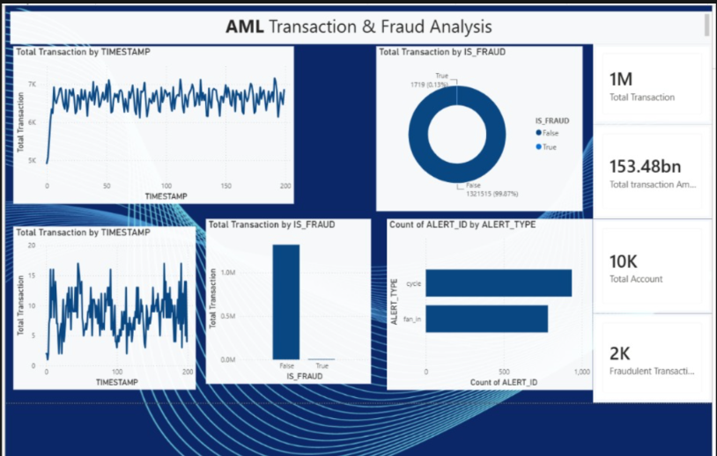

9. AML Tooltip Dashboard
The AML Tooltip Dashboard provides additional information when users hover their mouse over particular charts or data points.
Tooltips help users understand specific transaction details without navigating to another report page.
Main features:
- Displays additional information about selected data points.
- Provides more details about transaction categories.
- Helps users understand fraud-related information.
- Improves the overall dashboard experience.
- Makes data analysis more informative.
The tooltip feature allows users to explore additional information while keeping the main dashboard simple and organised.
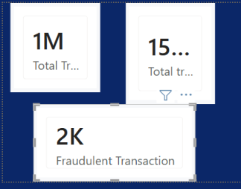

10. Accounting Analysis and Financial Results
Accounting analysis plays an important role in understanding the financial impact of transactions and fraudulent activities.
The dashboard helps analyse financial transaction values and monitor important financial information.
Major areas of analysis:
A. Transaction Value Analysis
The total transaction amount helps understand the overall monetary value of financial activities.
B. Fraud-Related Financial Analysis
Fraudulent transaction amounts can be examined to understand the financial exposure associated with suspicious activities.
C. Account Analysis
Account-related information helps understand transaction activities associated with different accounts.
D. Financial Monitoring
KPI cards and visual reports help users monitor transaction values and identify unusual financial patterns.
E. Decision-Making
The financial information presented through the dashboard supports better monitoring and helps organisations take appropriate action when suspicious activities are identified.
This analysis connects financial data with fraud monitoring and accounting-related decision-making.

11. Risk Management and AML Controls
Risk management is an important part of preventing financial fraud and money laundering.
The dashboard supports AML monitoring by helping users identify unusual transaction activities and suspicious patterns.
The major risk management areas include:
1. Fraud Identification
Identifying transactions marked as fraudulent helps users understand potential financial risks.
2. Suspicious Transaction Monitoring
Monitoring transaction patterns helps identify activities that may require further investigation.
3. Alert Monitoring
Alert information helps users understand different categories of suspicious activities.
4. Risk Assessment
Transaction and fraud information can support the assessment of potential financial risks.
5. Continuous Monitoring
The dashboard provides visual information that can help financial institutions monitor transaction activities regularly.
6. AML Compliance Support
The dashboard supports AML-related monitoring and analysis. However, it does not independently establish regulatory compliance or confirm criminal activity.

12. Overall Dashboard Insights
The overall dashboard provides a consolidated view of financial transactions, fraud activities and account-related information.
The major insights obtained from the dashboard include:
- Transaction Overview: KPI cards provide a summary of overall transaction activities.
- Fraud Distribution: The doughnut chart helps compare fraudulent and non-fraudulent transactions.
- Transaction Trends: The line chart helps understand changes in transaction activities over time.
- Alert Monitoring: Alert-related information helps identify categories of suspicious activities.
- Financial Understanding: Transaction amounts provide information about the monetary value of financial activities.
- Interactive Analysis: Slicers allow users to explore specific transaction categories.
- Risk Identification: Fraud-related visuals support the identification of potential financial risks.
Overall, the dashboard converts complex financial information into simple and understandable visual insights.

13. Benefits of the Dashboard
The AML Transaction & Fraud Analysis dashboard provides several benefits.
- Easy Data Understanding: Converts large amounts of financial data into understandable charts and visual reports.
- Fraud Monitoring: Helps identify and analyse fraudulent transactions.
- Time Saving: Reduces the effort required for manual transaction analysis.
- Better Decision-Making: Provides useful information for financial analysis and risk assessment.
- Interactive Analysis: Allows users to explore data using filters and slicers.
- Financial Monitoring: Helps monitor transaction amounts and account-related information.
- Improved Presentation: Presents complex data through professional and interactive dashboards.
- Risk Awareness: Helps users understand potential suspicious financial activities.

14. Conclusion
The AML Transaction & Fraud Analysis project demonstrates how Microsoft Power BI can be used to analyse financial transactions and support fraud monitoring.
The dashboard combines important KPIs, line charts, doughnut charts, interactive slicers and tooltip features to present financial information in a clear and organised manner.
Through transaction analysis, fraud distribution and alert monitoring, the project helps users understand financial activities and identify potential suspicious patterns.
Furthermore, the accounting analysis and risk management features demonstrate the importance of data analytics in the financial sector.
Overall, this project provides practical knowledge of Power BI, data visualisation, financial analysis, fraud detection concepts and Anti-Money Laundering monitoring.

15. Skills Developed Through This Project
Technical Skills | Knowledge Gained
Microsoft Power BI | Dashboard development
Power Query | Data cleaning and transformation
DAX | Creating calculated measures
Data Visualisation | Creating charts and graphs
Data Analysis | Analysing financial transactions
Financial Analysis | Understanding transaction values
Fraud Analysis | Understanding fraudulent activities
Risk Management | Understanding AML monitoring

Final Project Summary
Particulars | Details
Project Title | AML Transaction & Fraud Analysis
Domain | Finance and Data Analytics
Tool Used | Microsoft Power BI
Data Type | Financial Transaction Data
Main Focus | Fraud Analysis and AML Monitoring
Visualisations | KPI Cards, Line Chart, Doughnut Chart and Tooltips
Interactive Features | Filters and Slicers
Outcome | Interactive Financial Fraud Analysis Dashboard
Note: This report covers all 14 topics you listed. Exact numerical results, fraud percentages and financial findings have not been invented; they should be inserted from your actual Power BI dashboard.
My suggestion: Use this structure for your college project report. It covers the dashboard development, technical implementation, accounting analysis, AML concepts, insights and benefits in a professional order.

